Name:

Date:

# Archeology at Fort Frederica Student Handout

"The fortress was regular and beautiful, constructed chiefly with brick, and was the largest, most regular, and perhaps most costly of any in North America, of British construction: it is now in ruins…”

--William Bartram, Travels of William Bartram, 1791

# Illustration of Fort FredericaPhotograph of Fort Frederica

Illustration and photograph of Fort Frederica. (NPS photo.)

# Vocabulary Terms

**Archeology**: the study of humans within the past

**Artifact**: an item made and used by people in the past

**Context**: where an artifact or feature was found on a site, including how deeply buried

**Excavation**: scientific digging at a site during which archeologists record artifacts, features, and their contexts

**Feature**: non-moveable parts of a site such as building ruins, firepits, or wells

**Post-depositional processes:** the human actions or natural forces (e.g. wind, water, animal gnawing) that act on an object after it its original placement in the ground, possibly moving it to a new location

**Site**: area that contains archeological traces, either artifacts or features, of people of the past

# Part I: Introduction

Your teacher will show you a trailer for the Fort Frederica visitor film. After watching the trailer, list the kinds of artifacts you think archeologists found at Fort Frederica. What could these objects reveal about life within the fort and town?

# Part II: Fort Frederica, Then and Now

Read the background information about Fort Frederica and answer the questions below.

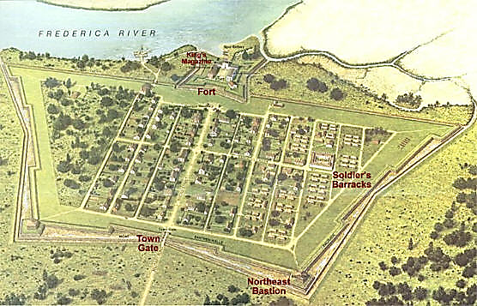

Aerial map of Fort Frederica. (NPS photo.)

In the early 18th century, France, Spain, and England fought for control of North America territories. Each power established colonies in an effort to establish, maintain, and expand their areas of control. Conflict between these colonies was constant as the three countries gained, lost, and regained power.

In the 1730’s, France controlled New Orleans in eventual Louisiana while Spain held St. Augustine in modern Florida. Spain wished to regain their lost territory within South Carolina and the newly-founded British colony of Georgia. England pressed in the opposite direction, looking to extend their power down the east coast and push the Spanish out of Florida entirely.

To address the Spanish threat, James Oglethorpe (Georgia’s famous founder) established Fort Frederica in 1736 on St. Simon’s Island, Georgia. The new settlement contained both a town and a military fort that defended the Frederica River. The fort was roughly square, with corner bastions and a spur battery on one side. Eventually it contained several buildings, including a blacksmith’s shop, two storehouses, and a guardhouse. These were all enclosed by tabby walls and a palisade.

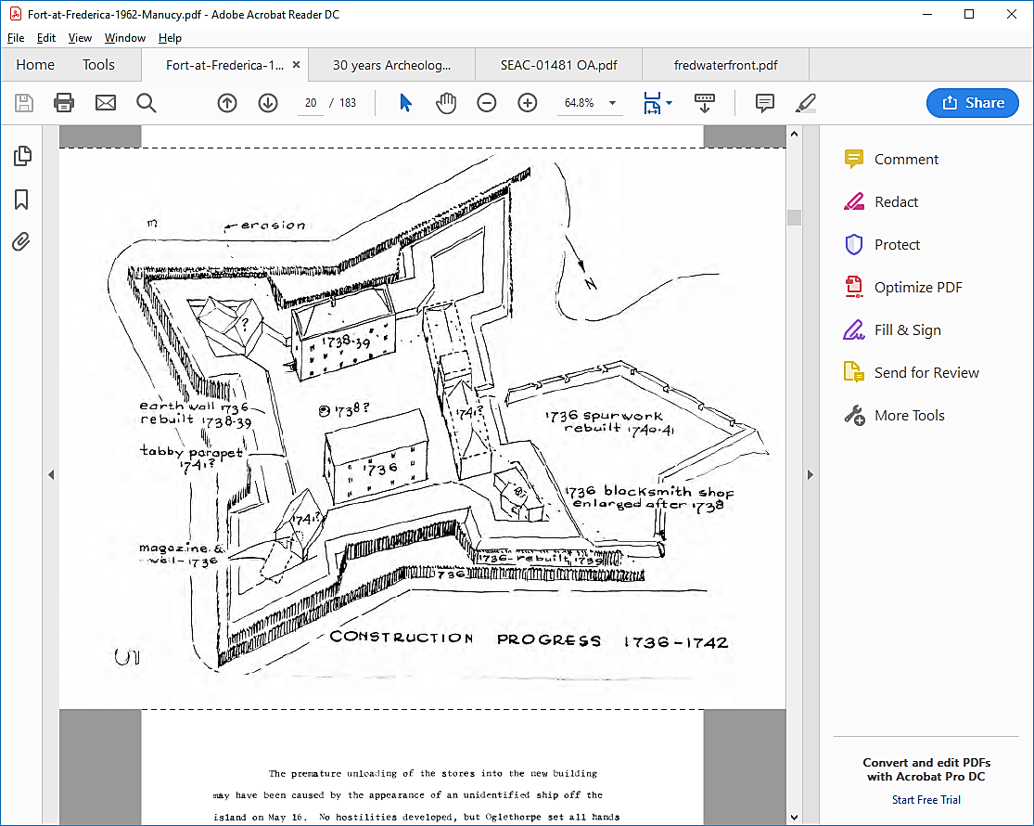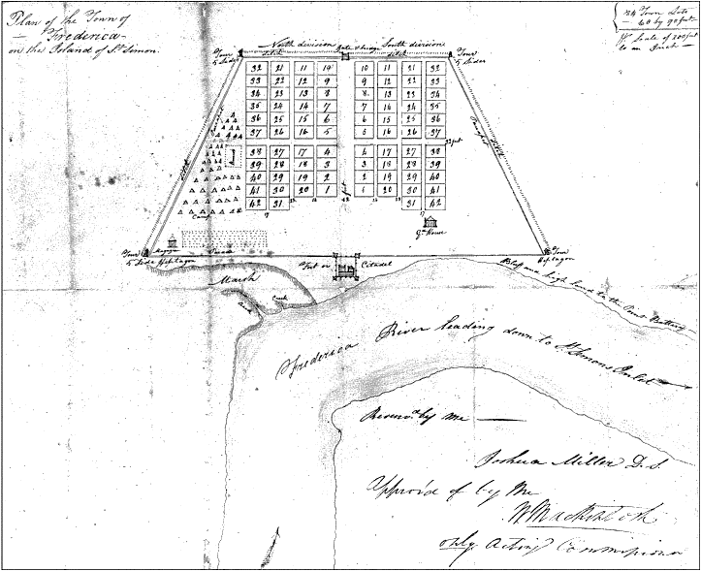

Plan of fort (left) and town (right). (Manucy, Albert C. The Fort at Frederica. Notes in Anthropology, vol. 5. The Department of Anthropology, Florida State University, 1962. Image 5; NPS photo.)

A second, outer earthen wall, a dry moat, and two palisades enclosed the fort and the town of Frederica. The town was built on land previously occupied by Yamassee Native Americans. It contained two areas of linear house lots separated by the main Broad Street. English settler families first lived in palmetto bowers (simple shelters made with branches covered by palmetto leaves) before creating more permanent houses on these lots. They grew tended personal yard gardens and raised crops on nearby land. However, because Fort Frederica was never meant to be a permanent settlement, families and soldiers depended heavily on distributed provisions.

Indeed, the fort only lasted a few years. In 1738, General Oglethorpe’s regiments launched an unsuccessful attack on the Castillo de San Marco in St. Augustine. Two years later, the Spanish retaliated and marched on Fort St. Simons in Georgia. The garrison there evacuated to Fort Frederica. There, during the Battle of Bloody Marsh, British forces led again by General Oglethorpe ambushed Spanish forces. Their victory caused the Spanish to retreat a final time to Florida and established British control over Georgia. No longer needed, the fort’s regiment was disbanded in 1748. Without the soldiers, Frederica’s local economy suffered and many of the town’s occupants left. In 1758, a fire destroyed what was left of the settlement.

Archeology is one way to know more about what daily life was like for people at Fort Frederica in the past. Excavated **artifacts** and **features** helped understand all aspects of life at Frederica, from how the fort and town were built down to the types of dishes their occupants ate and drank from every day.

**Question 1:** When and why was Fort Frederica built?

**Question 2:** Historical archeologists use both excavation and written documents to piece together what life was like in the past. Review the information above. Make a list of the types of documents archeologists might have used while researching the fort.

# Part III: Artifact Analysis

Archeologists excavated many types of artifacts from Fort Frederica. Some of these objects were modeled using 3D scanning. Explore the four artifacts below and answer the questions for each. (You can explore these models and others in more detail on the Sketchfab website *www.sketchfab.com*.)

***Artifact 1: Clay Smoking Pipe Bowl with British Coat of Arms***

**Question 1:** Examine this artifact. Read the tags on the artifact and description in the window below. Why might the pipe’s owner have chosen this detailed pipe over a plain one that was likely cheaper? Keep in mind that during the 18th century people often smoked together during leisure time so designs were very visible.

**Question 2:** Artifacts, like people, have “life stories” starting with when and where they were originally made to when they were discarded. Sometimes, artifacts obtain a second “life” when they are reused or modified into something new. Given what you know about this pipe, write its “life story” below. Include as many details as you can. Where was it made? How did it end up at Fort Frederica? How many “lives” does it have at this point in time?

***Artifacts 2 and 3: Wood Palisade Timber Artifact and Round Cannon Shot***

**Question 1:** Examine the timber artifact and cannon shot and read the information below each. What were these two artifacts used for?

**Question 2:** Archeologists can use **dendrochronology**, or the study of tree-rings, to date features and artifacts on a site. How would knowing what year this tree died or was cut down help understand how the fort was modified over time?

**Question 3:** Archeologists sometimes uncover objects **in-situ** (in place). These objects have not moved from when their original owners deposited them in the ground years ago. Their locations can reveal how individual spaces were used in the past for different tasks. Other times, objects were moved due to **post-depositional processes** such as wind, water, and human and animal actions move objects from their original locations. By knowing what kinds of processes are at work on a site, archeologists can better preserve and protect the area for future generations. Given what you know about Fort Frederica’s layout, where might you expect to find these two artifacts during an excavation?

**Question 4:** The timber artifact was found near other archeological remains of the fort palisade. However, the cannon shot was found in Lot 4S. This was once the home of Patrick Houstoun, Quartermaster of the Frederica Regiment and later President of the King’s Council. How do you think the cannon shot ended up in or near his home? What post-depositional processes might have occurred?

***Artifact 4: Earthenware Porringer***

**Question 1:** Archeologists sometimes use cross-mending (the piecing together of ceramic sherds, or pieces, from different areas of a site) to recreate an artifact. This porringer was found in Lot 8S that originally belonged to John Humble. Imagine that archeologists found the handle of this piece in the yard area between Lot 8S and 9S. How might they interpret their finding? What post-depositional processes might have occurred? How would these processes differ from those acting on the cannon shot?

**Question 3:** Like today, ceramics in the past were made into specific forms for certain purposes. Porringers were used for soup, stew, or other foods eaten with a spoon. Large earthenware bowls, like the one you see within this collection, were used as “milk pans” for dairying tasks including making cheese and butter. Stoneware jars and coolers, also seen here, stored provisions such as beans and lard. Imagine that archeologists found this porringer, a milk pan, and a storage jar in three different areas of the Humble home site. What might this distribution tell them about the different spaces inside the home?

**Question 4:** Archeologists can use ceramic residue analysis alongside faunal analysis (the study of animal bones) and archeobotany (the study of plant remains) to recreate the meals people of the past ate. Think about the conditions at Fort Frederica. List the various ways people obtained their food and other provisions.

**Question 5:** Using your answer to Question 4, how might scholars use this information to understand what the environment surrounding Fort Frederica was like? What might it mean if rationed food remains were more plentiful than crop remains?

# Part IV: Reflection

Review your answer to the Introduction question. After learning more about archeology at Fort Frederica, did your answer change? If you were an archeologist working at the fort, what other artifacts, features, and historical documents would you look for to know more about life there in the past?